## Lab 34: Using CleverHans with FGSM Attack

**Using CleverHans with FGSM Attack**

**Lab Manual**



**Disclaimer: The content is curated from online/offline resources and used for educational purpose only**

***Steps to implement CleverHans Library***

1. Visit the link: <https://colab.google/>
2. Click on ‘New Notebook’
3. Start typing the code given below
4. ***Installing the libraries***

pip install cleverhans

pip install tensorflow

1. ***Implementing the code for attack and visualization***

import numpy as np

import tensorflow as tf

import matplotlib.pyplot as plt

from tensorflow.keras.applications import MobileNetV2

from tensorflow.keras.applications.mobilenet_v2 import preprocess_input, decode_predictions

from tensorflow.keras.preprocessing import image

from cleverhans.tf2.attacks.fast_gradient_method import fast_gradient_method

# 1. Load pre-trained MobileNetV2 model

model = MobileNetV2(weights="imagenet")

# 2. Load image from Colab upload

img_path = "cat.jpg"  # Make sure this matches the name of the uploaded file

img = image.load_img(img_path, target_size=(224, 224))

x = image.img_to_array(img)

x = np.expand_dims(x, axis=0)

x_preprocessed = preprocess_input(x)

# 3. Get original prediction

preds = model.predict(x_preprocessed)

original_label = decode_predictions(preds, top=1)[0][0][1]

# 4. Create adversarial example using FGSM

epsilon = 0.05

adv_x = fast_gradient_method(model_fn=model, x=x_preprocessed, eps=epsilon, norm=np.inf)

# 5. Get adversarial prediction

adv_preds = model.predict(adv_x)

adv_label = decode_predictions(adv_preds, top=1)[0][0][1]

# 6. Plot original and adversarial images

plt.figure(figsize=(10, 5))

plt.suptitle("Original vs. Adversarial Image", fontsize=16)

plt.subplot(1, 2, 1)

plt.imshow(img)

plt.title(f"Original: {original_label}")

plt.axis('off')

plt.subplot(1, 2, 2)

adv_display = np.clip((adv_x[0] + 1) * 127.5, 0, 255).astype("uint8")  # from [-1,1] to [0,255]

plt.imshow(adv_display)

plt.title(f"Adversarial: {adv_label}")

plt.axis('off')

plt.show()

print("Attack successful?", original_label != adv_label)

1. Click on the ***folder icon*** and upload the image of the cat from your device.
2. Now click on ***Run All*** or ***Ctrl + F9*** to run all the cells

**Output:**

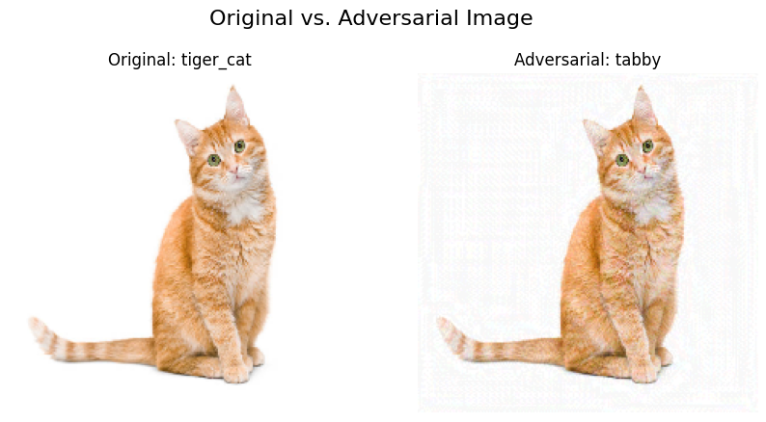

**Explanation**

We used CleverHans to generate an adversarial example from an image of a cat. Let us understand the output:

**What the Images Show:**

* ***Original Image:*** The model predicted: tiger_cat
* ***Adversarial Image:*** The model was fooled to predict: tabby

Both images look the same to a human eye (same orange cat, same pose), but a tiny, invisible noise was added to the adversarial image using the Fast Gradient Sign Method (FGSM).

***In this case:***

* Before attack: "tiger_cat"
* After attack: "tabby"

Since they are different, the attack was successful.

**Try on your own:**

If you want to try, when will the model fail - Make epsilon extremely small so that attack is weak.

Change the epsilon or ***eps*** from ***0.05*** to ***1e - 6***